Setting up a pan trap: Teacher note
Pan traps are a simple method to collect a sample of the insects that live in a particular area.
Group materials
- 3 small blue and 3 small yellow plastic dishes (all the same size)
- water containing a small amount of dishwashing liquid or salt
- 9 bamboo skewers (to be used if it is windy to hold the pans in place)
- 1 strainer
- 1 glass or plastic jar for observing/recording insects
- 1 pair of tweezers
- optional — red or white dishes may also be used as these may attract different insects
Method
1. Place three pans two metres apart, in several places within your study site.
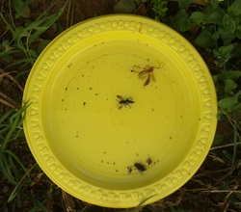
2. Place a few skewers around the pan, or through the side of the pan, and into the ground if it is windy.
3. Fill the base of each pan with about 1 cm of water.
4. Leave for about four hours.
5. Photograph the contents of the traps and/or strain the contents through the strainer. Alternatively, draw and record written descriptions of the animals collected.
6. Use tweezers to handle the insects and place in the jars to retain for later identification.
Safety note: Please ensure students exercise caution with the insects caught in the pan trap as some insects can sting or bite. Please ensure students DO NOT handle spiders, bees or wasps.
It is against the law to collect lizards, frogs and any other animals that have a backbone (vertebrates). It is very unlikely that any will be trapped in the pans, but any that have been trapped should be released immediately.
More information about pan traps can be found on the website Yellow pan traps (Queensland Museum) http://www.qm.qld.gov.au/Find+out+about/Animals+of+Queensland/Insects/Collecting+insects/Yellow+Pan+Traps

